* 2.27 - Meeting Record

Objectives:

Decide topic: Urbanization in Africa

Decide to use webflow as our landing page

Every Thursday 8 p.m. (Canberra time) meeting

Individual work (Due by next Meeting):

Xi Chen: Working on Landing Page

Yifei Tao: set up urls and server side

Qixuan Ren & Yuexin Chen: Readme file on gitlab

* 3.2 – Meeting Record

Welcome our new team member

Individual work (Due by next Meeting):

Xi Chen & Fei Wu: Working on Team charter

Yifei Tao & Qixuan Ren & Yuexin Chen: Working on Project Overview Doc

* 3.4 – Meeting Record

Change the topic: Agriculture in Africa (decided by vote)

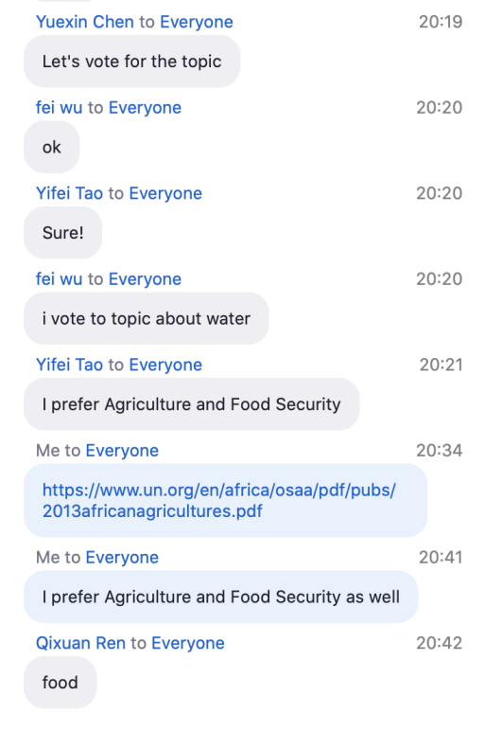

Think about key modules: natural calamities, plague of locusts, crop yield...

Discuss the flow path of this project

Modify the landing page

Individual work: (Due by next meeting)

Xi Chen & Fei Wu: team charter

Xi Chen: design document cover

Yifei Tao & Qixuan Ren & Yuexin Chen: do the part 1, part 2, part 3, respectively (Project Overview Doc)

* 3.11 – Meeting Record

imagine and plan the final results (dashboard)

Analyse challenges and issue

Individual work: (Due by next meeting)

Xi Chen & Qixuan Ren: research the problems African agriculture faces and the causes.

Fei Wu & Yifei Tao & Yuexin Chen: research on tools and data of DE Africa (find which tool applies to this project? How to solve problem by tools?)

Note: focus climate, write info to skeleton.doc

* 3.19 – Meeting Record

Define the point of view of our project, and select a specific country(South Africa) to narrow the scope of the study.

Discuss the problem, solution and challenge.

Individual work:

Task 1(due by 3/22):

Stakeholder analysis：Qixuan

Ecosystem mapping: Xi & Yifei

Mapping relationship stakeholder with issues: Fei & Yuexin

Task2 (due by next meeting):

Agriculture status in South Africa: Xi & Fei

POV: qixuan & yuexin & yifei

* 3.25 – Meeting Record

Be clear about the goal of the project (achieve food safety, food supply stability, uniform distribution ).

extract some problems South Africa Agriculture faces and analyse solutions related to DEA

Individual work(due by next meeting):

Do some research and write the Project Report:

Executive summary: Xi

1-Introduction: Yifei

2-literative review: Qixuan

3-Methology: Yuexin (3.1 3.2 3.5), Fei (3.3 3.4 intro)

* 4.1 – Meeting Record

Discuss the each parts of Report

Individual work(due by 4.15)

Report4-7

Grain yield: Fei Wu

Natural calamities: Qixuan Ren & Yuexin Chen

Land-use program: Yifei Tao & Xi Chen

* 4.15 – Meeting Record

Discuss the prototype (eg: app or website), and summary report4.

Individual work(due by next meeting)

Integrate part4-6 of report: Qixuan Ren & Yuexin Chen & XiChen

Make some charts and pictures: Fei Wu & Yifei Tao